Template – Popup, Expand/Collapse Panel & Google Map Components
The template named “Template – Popup, Expand/Collapse Panel & GoogleMap Components” is applicable to Anthology Student.

Purpose and Outcome
This template provides an anonymous form sequence and supporting workflow for the use of Popup, Expand/Collapse Panel & GoogleMap components in a form.

Prerequisites
The template was built with Forms Builder using the applications listed below. The template is forward compatible with later versions of the listed applications.
Application | Compatibility Version
Forms Builder Designer and Renderer | Compatibility Matrix
Web Client for Anthology Student
Workflow Composer
Packages installed from Package Manager in Workflow Composer | Activities and Contracts (V2)  Contracts (V1)  Forms Builder Contracts  Note: Ensure that the Forms Builder Contracts package used in Workflow Composer is aligned with the version used in the Forms Builder. Additionally, confirm that both Activities and Contracts (V1) and Activities and Contracts (V2) packages in Workflow Composer match the versions used in the Student Web Client to avoid compatibility issues.  It depends on which product is being used, for example:  For CRM:  Activities And Contracts (CRM)  Forms Builder Contracts
Workflow Tracking Database | N/A
Staff STS | 3.3.x

Prerequisites for Use of Google Maps
Google Maps require a valid API key that must be configured in the Forms Builder Settings.
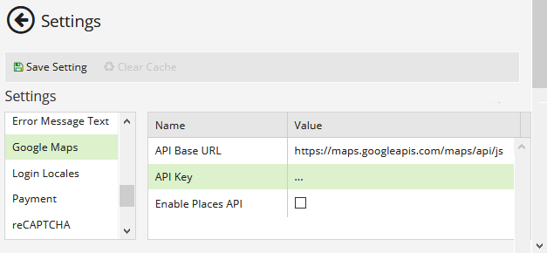
In addition, fees may apply depending on the usage of Google Maps in a production environment.
For details, see https://cloud.google.com/maps-platform/pricing.

Step 1: Download and Import the Template
- Download the template file to your environment (local drive or network location).
- Log into Forms Builder and select the Export/Import tile.
- Select the Import tab.
- Click Select exported file and navigate to the downloaded template file (xml).
- Click Import.
Note: Import may fail if same files name is already available in environment or overwrite option.

- Export/Import

The “GoogleMaps Example” and “Default-Confirmation” forms will be imported.

Step 3: In Form Designer…
- From the Forms slide out, select the GoogleMaps Example form.
- Customize the form for your environment. Modify properties on fields/components to make them required, etc., or add/remove fields on the form.
- Fields and Components
- Save the form.

Step 4: In Sequence Designer…
- Locate the GoogleMaps Example sequence in the Sequences pane.
- Click Save As to create a copy of the sequence/workflow and customize the copy for your use. This way you can always refer to the original sequence/workflow you downloaded.
- (Optional) Customize the sequence properties for your environment.
- (Optional) Add a custom style (theme) for your campus.
- Themes
- Select your saved sequence in the Sequences pane.
- In the Properties Pane, as End State Form, select the imported “Default-Confirmation”.
- Save the sequence.

Step 5: In Workflow Composer…
You do not need to modify anything in the workflow.
- (Optional) Open the workflow for your saved sequence.
- Opening Workflows for Sequences
- (Optional) Explore the workflow to get an understanding of the workflow logic.
- State Machine Workflows

Step 6: In Forms Renderer…
Select your sequence and try it out!
- Sequence List
- Find your sequence and copy the URL to the clipboard.
- Paste the URL into a browser and complete the form sequence.

Step 6: Lastly…
Once your updated sequence has been tested successfully, it is recommended that you disable the workflow for the original Template version.
- In Workflow Composer, in the Server section of the ribbon, click Open.
- Find the workflow named GoogleMaps Example.
- Clear the Enabled check box and click Save.

